Traffic Density Monitoring Using IoT, and Cloud

Model for Prediction

Sujatha Rajkumar Professor Grade 1
Department of Electronics and Communication Engineering (SENSE) Vellore Institute of Technology,Vellore
Tamil Nadu, India

Ch Benish sai 23BEC0429
Department of Electronics and
Communication Engineering (SENSE) Vellore Institute of Technology,Vellore Tamil Nadu, India
KVSS Sai Ram 23BEC0333
Department of Electronics and Communication Engineering (SENSE) Vellore Institute of Technology,Vellore
Tamil Nadu, India
Surya AVN 23BEC0357
Department of Electronics and Communication Engineering (SENSE) Vellore Institute of Technology,Vellore
Tamil Nadu, India

Category: Both hardware and software
Abstract— Urban traffic congestion remains a critical challenge in growing cities, causing productivity loss, fuel waste, pollution, and delayed emergency responses. Conventional fixed-time traffic lights are unable to adapt to real-time conditions, often worsening delays. This paper presents an intelligent traffic management system built on a low-cost edge–cloud framework to improve traffic efficiency and emergency response. A Raspberry Pi serves as the local hub, processing live video from webcams to estimate vehicle density with minimal latency. Processed data is transmitted to the cloud, where adaptive algorithms, including reinforcement learning and fuzzy logic, dynamically optimize signal timings. A key feature is emergency vehicle detection, which creates an immediate green corridor for ambulances and fire services. By integrating IoT, edge computing, and adaptive control, the proposed system reduces congestion, lowers emissions, and enhances public safety, offering a scalable and practical approach for smart city transportation.

Keywords— Intelligent Transportation Systems, Traffic Light Control, IoT, Real-Time Video Analytics, Cloud-Based Systems, Emergency Vehicle Detection.

INTRODUCTION
Effective urban traffic congestion has become an everyday struggle in most growing cities, affecting not only commuters but also the broader functioning and sustainability of urban environments. The sight of long queues of vehicles at intersections, continuous honking, and slow-moving traffic has become so common that many people have gradually accepted it as an unavoidable part of city life. However, beneath these daily inconveniences lies a deeper and more serious impact. Congestion results in significant productivity loss, as individuals and commercial vehicles spend excessive time stuck on the road. The extended idling and stop-and-go driving patterns contribute to higher fuel consumption, directly increasing transportation costs for individuals and businesses. Moreover, the constant burning of fuel in densely packed traffic contributes heavily to air pollution, worsening urban air

quality and public health conditions. The consequences become even more severe when traffic delays affect emergency services. For ambulances, fire trucks, and police vehicles, response time is critical. A delay of even a few minutes at a traffic signal can determine whether a life is saved or lost, whether property is protected or damaged beyond recovery. This underscores that urban traffic congestion is not merely an inconvenience—it is a public safety concern. The core issue, however, Is not limited to the increasing number of vehicles on the road. A major contributing factor is the inefficiency of existing traffic control systems. Most intersections in developing and even some developed cities still use fixed-time traffic signal scheduling. These systems operate on predetermined intervals that do not change based on real-time road conditions. As a result, a lane heavily packed with vehicles may receive the same green signal duration as a lane that is nearly empty, causing unbalanced traffic flow. Therefore, there is an urgent need for smart, dynamic, and context-aware traffic management solutions that can respond to conditions in real time and optimize flow efficiently. To address these challenges, this research proposes a next-generation intelligent traffic management system that improves traffic flow while prioritizing emergency vehicles during crucial moments. The system is designed using a low-cost edge- computing approach, making it affordable and scalable for widespread deployment. A Raspberry Pi functions as the local processing hub placed at the intersection. Webcams continuously capture real-time traffic footage, which the Raspberry Pi processes immediately, eliminating the need to send raw video to remote servers. This reduces latency and enables fast and reliable decision- making directly at the intersection. In parallel, the cloud layer supports adaptive optimization. Traffic metadata transmitted from the edge is used by reinforcement learning and fuzzy logic algorithms to analyze changing road conditions and adjust signal timings dynamically. This ensures that traffic signals are not static but responsive, changing intelligently based on actual demand and flow.

LITERATURE SURVEY
Recent intelligent transportation systems integrate computer vision, IoT, and adaptive traffic control for real-time intersection responsiveness. A YOLOv9-based IoT framework for emergency vehicle detection achieved 99.8% accuracy with 80 ms latency, outperforming conventional CNN/DNN for urban adaptive traffic signaling [1]. A Raspberry Pi-based ambulance prioritization system using laser diodes and LDR sensors enabled dynamic green- light allocation, reducing response time by 35%, but performance declined in fog/heavy rain due to optical interference [2]. The CrossTime mobile app integrated smartphone motion sensors with OpenStreetMap to estimate crossing waiting times, highlighting crowd-sensing in multimodal traffic management, though direct signal control was outside its scope [3]. Night-time traffic signal detection remains challenging due to low illumination and noise; the EG-TLR framework addressed this with residual denoising and mixed attention, achieving AP50 = 79.83% and improved night- time traffic perception [4]. Cost-effective adaptive traffic systems using Arduino-based control integrated ultrasonic, acoustic sensing, and manual override, reinforcing sensor fusion for real- time emergency prioritization at intersections [5]. A lightweight YOLOv5 model with EfficientViT and cross-scale feature fusion achieved 204 FPS and 95% precision on edge hardware, confirming advanced visual system deployment feasibility in embedded environments [6]. Cloud-integrated solutions for large- scale traffic corridor management, like a combined RFID–GPS–LTE framework, enabled real-time ambulance tracking and automated green-light routing, demonstrating scalability for metropolitan emergency management [7]. Reinforcement Learning-based adaptive control, as shown by Dwizarah et al., improved intersection performance under heavy congestion, but practical deployment faces safety and real-time convergence limits [8]. Ensemble and boosting-based detection models enhanced robustness under occlusion, glare, and variable lighting, outperforming single detectors in real-time signal recognition [9]. Raspberry Pi systems with lightweight CNNs validated low-cost smart traffic for vehicle density estimation and dynamic signal adjustment [10]. Offline reinforcement learning, like D2TSC, enabled safe policy development from historical datasets without live exploration, supporting safety-critical traffic management [11]. Literature surveys on RL-driven traffic systems highlight challenges in reproducibility, multi-agent convergence, and evaluation standardization [12]. Hybrid vision approaches combining YOLOv5s for detection and AlexNet for signal state classification achieved strong

performance with reduced computational load, suitable for embedded roadside deployments [13]. Benchmarking YOLO, YOLOX, Faster R-CNN, and SSD concluded that YOLO-family models offer the best speed–accuracy trade- offs for autonomous transport [14]. Two-stage CNN frameworks for arrow-signal interpretation effectively managed complex urban scenarios with frequent occlusion and varying viewpoints [15]. Studies combining CNN classifiers with prior spatial maps reduced false detections across sequential frames, improving signal state consistency [16]. Earlier two-stage approaches using color–intensity region proposals and CNN classification achieved high detection accuracy (99.6%), showing the relevance of structured preprocessing in complex traffic scenes [17]. Small-object-optimized SSD models maintained real-time performance detecting miniature signals in dense urban imagery [18]. Initial IoT-enabled Raspberry Pi systems validated adaptive signal timing based on camera-based vehicle counting [19], while HSV color segmentation and contour-based detection formed the basis for traffic signal recognition on resource-constrained hardware [20].

Research Gap
Although extensive research has explored emergency vehicle detection, adaptive signal control, and traffic light recognition, existing systems rarely achieve unified integration of all functional components into a single scalable framework. Many solutions address only isolated elements such as detection accuracy, routing, or night-time visibility. Additionally, several high-performance models rely on hardware resources unsuitable for real-world roadside deployment, while low-cost prototypes often suffer from environmental sensitivity or limited precision. There remains a need for a system that combines real- time detection, environmental robustness, low-latency control, cloud-assisted data intelligence, and edge-level deployability to provide reliable and scalable emergency vehicle prioritization across diverse urban conditions.

Summary
The literature indicates clear progress in the use of deep learning, IoT infrastructures, reinforcement learning, and embedded sensor fusion for intelligent traffic management. However, the fragmented nature of existing solutions limits large-scale deployment and operational reliability. The proposed system addresses these limitations by integrating high-accuracy emergency vehicle detection, environment-tolerant signal recognition, cloud-supported routing intelligence, and lightweight edge implementation into a unified adaptive traffic control framework. This approach provides a practical pathway toward efficient, scalable, and real-time emergency traffic management in smart city environments.

NOVELTY OF THE WORK
The primary innovation of this research lies in its integrated and real-time approach to adaptive traffic management and emergency vehicle prioritization, implemented using low-cost edge computing. While previous systems either focus on signal timing optimization, emergency clearance, or general traffic monitoring in isolation, the novelty of the proposed framework is fourfold:
  - Edge-Based Real-Time Traffic Analysis: Unlike traditional cloud-dependent or manually controlled systems, the proposed framework performs on-site processing of live traffic camera feeds using Raspberry Pi. This eliminates network latency, reduces reliance on external servers, and ensures immediate response. The system continuously evaluates vehicle density and adjusts signal timing autonomously, enabling responsive and localized decision-making.
  - Adaptive Signal Control through Intelligent Algorithms: The system employs reinforcement learning and fuzzy logic techniques to dynamically optimize signal durations based on real- time traffic flow. Unlike fixed-timer mechanisms commonly used in cities, the signals continuously adapt to congestion levels, preventing unnecessary waiting, reducing idle emissions, and improving road throughput during varying peak and off-peak conditions.
  - Automated Emergency Vehicle Prioritization (Green Corridor): A key innovation is the video- based emergency vehicle detection mechanism, which instantly identifies ambulances and fire service vehicles and creates a temporary green corridor without requiring RF tags, siren sensors, or manual overrides. This ensures uninterrupted emergency movement, significantly improving response times where delays can be life-critical.

PROPOSED METHODOLOGY
The proposed intelligent traffic control framework is implemented using a robust and modular three-tiered system architecture designed to ensure real-time responsiveness, high scalability, and reliable emergency prioritization. The architecture is organized into the Sensing and Intersection Acquisition Layer, the Edge Computing and Local Decision Layer, and the Cloud Analytics and Optimization Layer, each performing coordinated but independent functional roles.

Sensing and Intersection Acquisition Layer
This foundational layer consists of webcam-based visual sensing units installed at traffic intersections for
continuous monitoring of approaching vehicle lanes. Unlike earlier systems relying on manual counters or single-sensor triggers, this layer provides full-scene contextual awareness through live video streams. Key functions in this layer include:
- Real-Time Traffic Monitoring: A standard IMX219 or USB webcam captures continuous road footage across defined Regions of Interest (ROI), ensuring lane-wise density measurement.
- Emergency Vehicle Visual Signature Detection: Video frames are analyzed for identifying ambulances and fire-trucks using color-pattern cues (e.g., emergency livery and beacon light signatures) and trained YOLO object classes.
- Lane-Specific Density Estimation: Vehicles are categorized (car, bus, truck, two-wheeler), counted, and grouped per lane to derive real-time congestion metrics.
The processed metadata (vehicle counts, timestamps, emergency vehicle flag) is periodically transferred to the next tier, minimizing bandwidth usage by avoiding raw video transmission.

Edge Computing and Local Decision Layer
At the core of the system is a Raspberry Pi-based Edge Gateway, which runs real-time video analytics and local control logic. This enables low-latency decision-making directly at the intersection, eliminating dependency on cloud round-trip delays. Key components of this layer include:
      - On-Device Object Detection: The YOLOv5/YOLOv7 model operates locally on the Raspberry Pi to detect and classify vehicles from frame streams in real time.
      - Real-Time Density Logic: Frame-wise vehicle counts are aggregated to determine lane priority and traffic load conditions.
      - Immediate Emergency Corridor Enforcement: Upon detecting an ambulance or fire truck, the edge system overrides standard signal cycles and triggers a temporary green corridor to clear the path.
      - Signal Control Execution: GPIO-controlled relay or traffic light controller interface transmits signal switching commands based on the decision engine.This localized autonomy ensures that the system functions even under intermittent network conditions, making it reliable for real-world deployment.

Signal Control and Actuation Layer
This layer handles the final execution of signal timing decisions by interfacing directly with the traffic signal controller.
      - Controller Interface: The Raspberry Pi communicates with the traffic signal hardware through GPIO pins or a relay driver module to switch signal states.
      - Adaptive Timing Adjustment: Green signal duration is increased for lanes with higher traffic density and reduced for lanes with lower congestion to optimize flow.
      - Emergency Override Logic: When an ambulance or fire truck is detected, the system overrides the current signal cycle to establish a temporary green corridor.
      - Continuous Feedback Loop: The signal state is updated repeatedly as new traffic data is processed, ensuring the system adapts continuously to changing road conditions.
This layer enables dynamic and real-time actuation of traffic lights, ensuring smooth flow and prioritization when required.

FUNCTIONAL BLOCK DIAGRAM & SYSTEM DESIGN DETAILS

The intelligent traffic management system continuously monitors real-time road conditions using live video streams captured by cameras at major intersections. These frames are processed locally on a Raspberry Pi, enabling low-latency edge computation. A YOLO-based object detection model identifies various vehicle types—cars, buses, two-wheelers, and trucks—and accurately estimates lane-wise traffic density. Using this information, the system analyzes the traffic load on each lane and dynamically adjusts signal timings instead of relying on fixed cycles. Green light durations are intelligently extended or shortened based on actual vehicle density, helping reduce unnecessary waiting, prevent congestion, and maintain smoother movement across intersections. By processing data at the edge and reacting instantly to changing conditions, the architecture minimizes decision delays, reduces fuel wastage caused by idle times, and contributes to lower emissions. Overall, it provides a more efficient, responsive, and sustainable approach to managing traffic flow in modern urban environments.

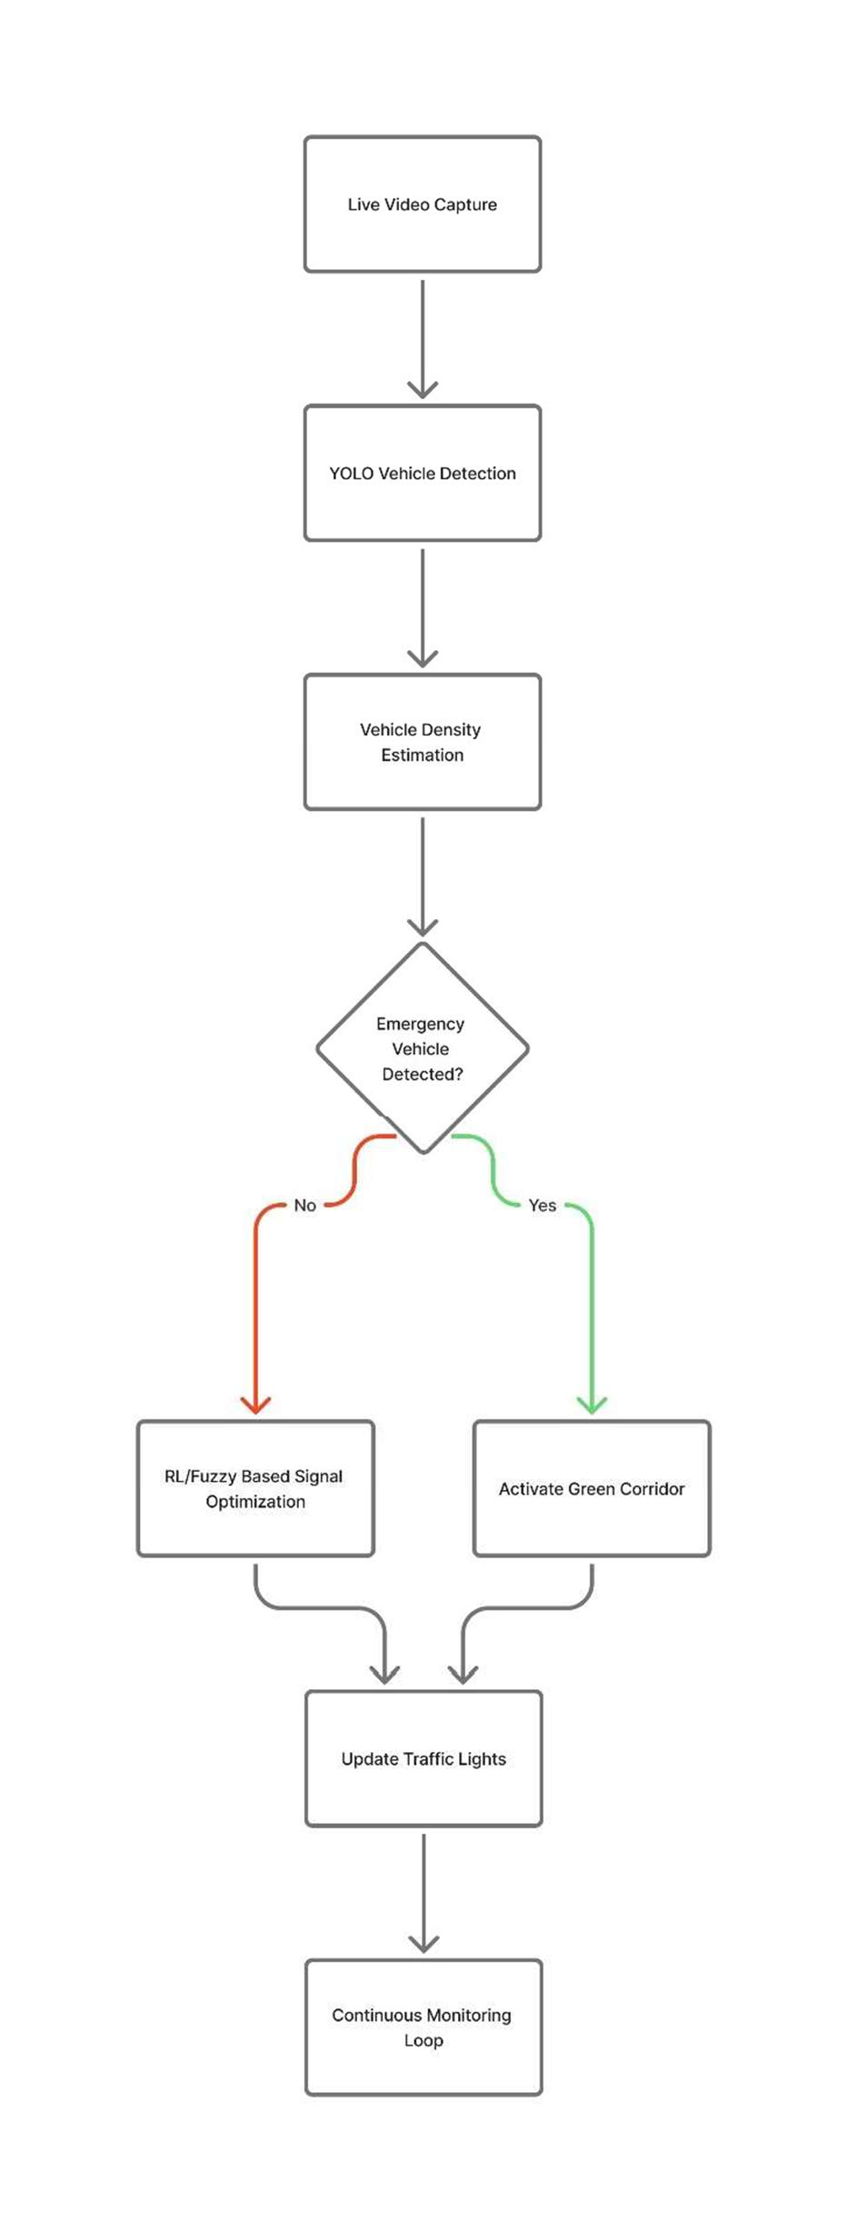
Fig. 5.1. Flowchart of the Proposed Intelligent Traffic Management System

This flowchart illustrates how live video is processed to detect vehicles and determine traffic density at an intersection. If an emergency vehicle is identified, a green corridor is activated; otherwise, the system optimizes signal timing and continuously updates the traffic lights.

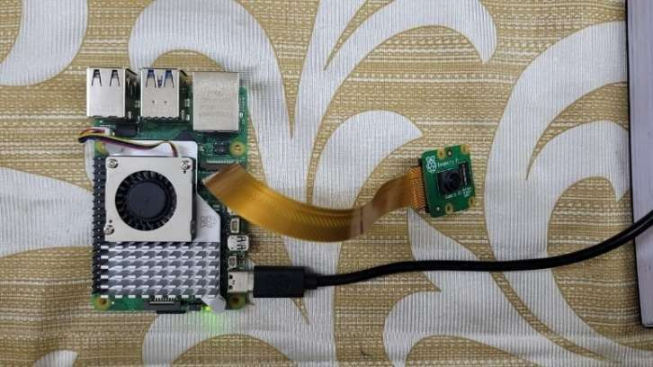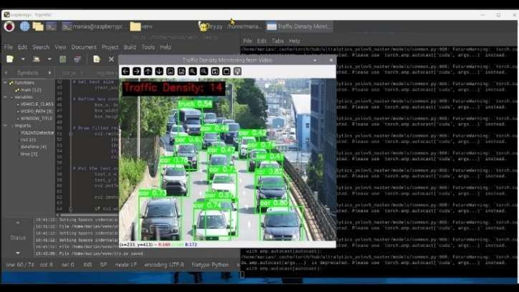

Fig.5.2. Raspberry Pi 4 with Camera Module Connection

This hardware setup captures live video feed at the traffic intersection. The Raspberry Pi processes the video in real- time using the YOLO model for vehicle detection and density estimation, enabling low- latency traffic signal control.
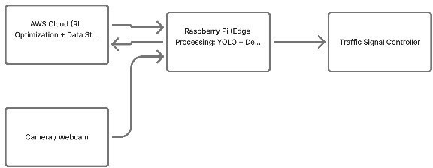
Fig. 5.3. Block Diagram of the Proposed Edge–Cloud Traffic Control Framework

This block diagram shows how the camera captures live traffic video, which is processed by the Raspberry Pi for vehicle detection and decision-making. The cloud assists with optimization and data storage, and the processed output is used to control the traffic signal in real time.

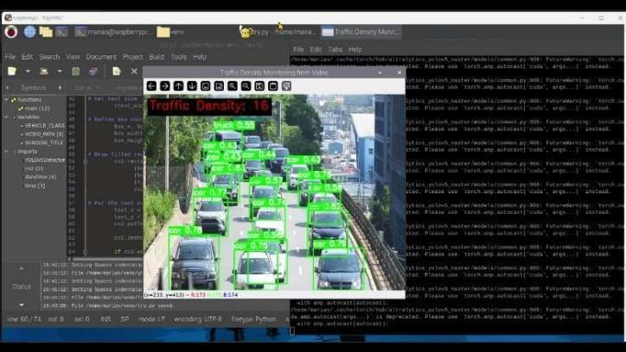
Fig. 5.4 a
Fig. 5.5 b

Simulation of the model by playing a video to detect the traffic and collect data.

RESULTS
The framework's performance was validated through the successful deployment and operation of its key components, as illustrated by the system dashboards. The Grafana dashboard visualizes real-time data streams, including voltage, power consumption from the PZEM-004T and CO2 concentration from the MQ135 sensor. This demonstrates the system's capability for live environmental and energy monitoring, allowing operators to track key performance indicators and identify anomalies. The Home Assistant interface serves as the central control panel, providing an intuitive overview of all connected devices, from lighting and fans to sensor states like door status and server room temperature. This unified view confirms the successful integration of diverse hardware into a single, cohesive system. Finally, the MotionEye dashboard provides a reliable live video feed for security surveillance. The stability and responsiveness of these dashboards validate the effectiveness of the containerized microservices architecture running on the Raspberry Pi 4B.
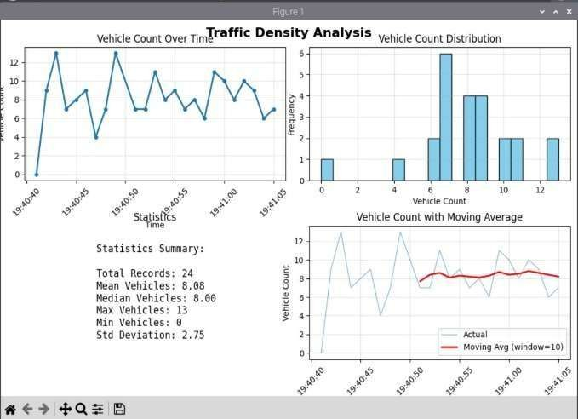

Fig. 6.1. Statistical graphs generated locally using python

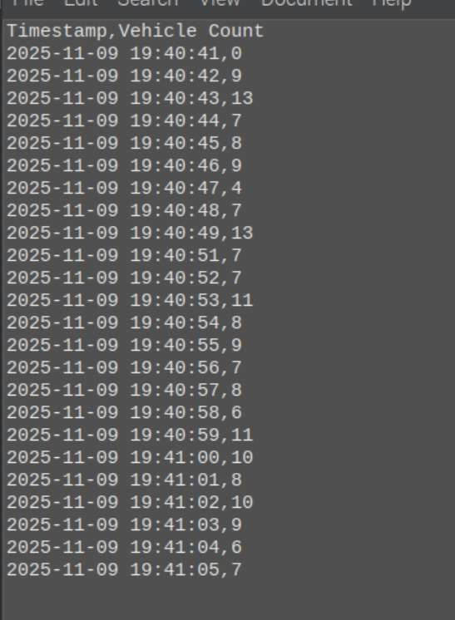
Fig. 6.2. Traffic Density without respective time stamps
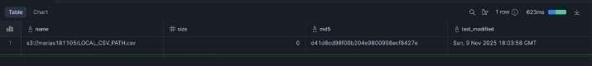
Fig. 6.3 Output in Snowflake
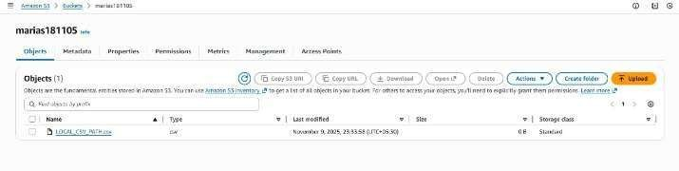

Fig. 6.4 Output in AWS S3
Codes and Video:
https://drive.google.com/drive/folders/16VHet_siwr0zXQgVvRqlVOUDE2xo5I0g?usp=sharing

CONCLUSION AND FUTURE WORK

The proposed intelligent traffic management system successfully addresses the limitations of conventional fixed- time traffic signals by incorporating real-time video analytics and adaptive decision-making. By deploying YOLO-based vehicle detection on a Raspberry Pi edge device, the system is able to
estimate traffic density and dynamically adjust signal timing with low latency. The introduction of emergency vehicle recognition ensures the formation of a green corridor, significantly reducing response delays for ambulances and fire services. Overall, the system improves traffic flow efficiency, reduces idle fuel consumption, and enhances safety in urban transportation networks. Its low cost and modular architecture make it suitable for large-scale deployment across smart cities.
Future developments can focus on enhancing detection accuracy under challenging conditions such as night-time, heavy rain, or poor lighting by integrating thermal or infrared cameras. Reinforcement learning models may be further trained on larger real-world datasets to improve adaptability across diverse traffic patterns. The system can also be extended to support multi-intersection synchronization to optimize traffic flow on a city- wide scale. Additionally, integrating communication between vehicles (V2I) could enable even faster and more reliable emergency routing decisions. Finally, a dedicated mobile or web-based control dashboard may be developed for real-time monitoring and manual override capabilities by traffic authorities.

REFERENCES

- T. Chen, Y. Zhang, M. Li, and H. Wang, “A Lightweight Traffic Light Detection and Recognition Model Based on YOLOv5,” Proc. 5th Int. Conf. Sensors Inf. Technol. (ICSI), pp. 580–587, 2025.
- A. Khadhim, R. Ahmed, and F. Hassan, “Cloud- Based Ambulance Tracking and Movement Facilitation Through Traffic Light Control,” Proc. 7th Int. Congr. Human-Computer Interact., Optim. Robot. Appl. (ICHORA), pp. 1–6, 2025.
- L. Ciabattini, M. Rossi, and F. Giannotti, “CrossTime: A Mobile Application for Smarter Pedestrian Navigation and Traffic Light Awareness,” Proc. 26th IEEE Int. Conf. Mobile Data Manag. (MDM), pp. 252–257, 2025.
- A. Kumar S., P. Mehta, and N. Gupta, “Automated Traffic Light Control System for Ambulance Using Laser Signals and Raspberry Pi,” Proc. Int. Conf. Artif. Intell. Data Eng. (AIDE),
pp. 920– 924, 2025.
- Z. Yao, L. Feng, and H. Zhou, “Night-Time Traffic Light Recognition Based on Enhancement- Guided Object Detection,” IEEE Trans. Syst., Man, Cybern.: Syst., vol. 55, no. 6, pp. 4410–4422, Jun. 2025.
- A. Dwizarah, M. Rahman, and T. Nguyen, “Adaptive Traffic Light Controller with Reinforcement Learning for Reducing Traffic Congestion,” Proc. IEEE Region 10 Conf. (TENCON),
pp. 1554– 1557, 2024.
- G. S. H. Karedla, R. Sharma, and P. Reddy, “An Intelligent Traffic Management System with Adaptive Traffic Light Control Based on Vehicle Density Estimation,” Proc. 4th Int. Conf. Mobile Netw. Wireless Commun. (ICMNWC), pp. 1–8, 2024.
- G. Wei, Z. Zheng, V. Gayah, and Z. Li, “Deep Reinforcement Learning Based Traffic Signal Control: A Comparative Analysis,” Procedia Computer Science, vol. (Proc. of …), 2023, doi: 10.1016/j.procs.2023.03.036.
- “Deep reinforcement learning for traffic signal control with consistent state and reward definitions,” Elsevier / Expert Systems with Applications, 2023, doi: 10.1016/j.eswa.2023.122005
- “A survey of reinforcement and deep reinforcement learning for coordination in intelligent traffic light control,” A. Saadi, N. Abghour, Z. Chiba, K. Moussaid, S. Ali, 2023, doi:10.21203/rs.3.rs- 3225879/v1.
- Z. Niu and K. Li, “Traffic Light Detection and Recognition Method Based on YOLOv5s and AlexNet,” Appl. Sci., vol. 12, no. 21, p. 10808, Oct. 2022.
- W. Liu, H. Zhao, X. Sun, and T. Zhang, “Image- Adaptive YOLO for Object Detection in Adverse Weather Conditions,” Proc. AAAI Conf. Artif. Intell., pp. 1792–1800, 2022.
- M. Miletić, E. Ivanjko, M. Gregurić, and K. Kušić, “A review of reinforcement learning applications in adaptive traffic signal control,” IET Intell. Transp. Syst., vol. 16, no. 10, pp. 1269– 1285,
Oct. 2022. doi:10.1049/itr2.12208.
- Y. Zhao, Y. Feng, Y. Wang, Z. Zhang, and Z. Zhang, “Study on Detection and Recognition of Traffic Lights Based on Improved YOLOv4,” Sensors, vol. 22, no. 20, 7787, 2022, doi:10.3390/s22207787.

- “Traffic lights Detection and Recognition using YOLOv5s + AlexNet,” Applied Sciences, 2022 (Paper describing combining YOLOv5s for detection + AlexNet for recognition) doi: see the journal version.
- “Intelligent Traffic Signal Control with Proximal Policy Optimization (PPO),” ACM / IEEE conference, 2021 or 2022.
- S. Seid, M. A. Mohammed, and T. Saeed, “A Low- Cost Edge Computing and LoRaWAN Real-Time Video Analytics for Road Traffic Monitoring,” Proc. 16th Int. Conf. Mobility, Sens. Netw. (MSN), pp. 762– 767, 2020.
- J. Barthélemy, M. Verstaevel, J. Forehead, and P. Perez, “Edge- Computing Video Analytics for Real- Time Traffic Monitoring in a Smart City,” Sensors, vol. 19, no. 9, 2019.
- G. Zheng, X. Zang, N. Xu, H. Wei, Z. Yu, V. Gayah, and K. Xu, “Diagnosing Reinforcement Learning for Traffic Signal Control,” arXiv preprint, 2019, doi:10.48550/arXiv.1905.04716.
- F. Kerouh and D. Ziou, “Real-Time Android Application for Traffic Density Estimation,” IEEE Access, vol. 6, pp. 49896– 49901, 2018.

